Practical: 2 | Implementation and Time analysis of linear and binary search algorithm
05/08/2026

Aim:To implement Linear Search and Binary Search algorithms and analyze their time complexity and performance.

Algorithm:

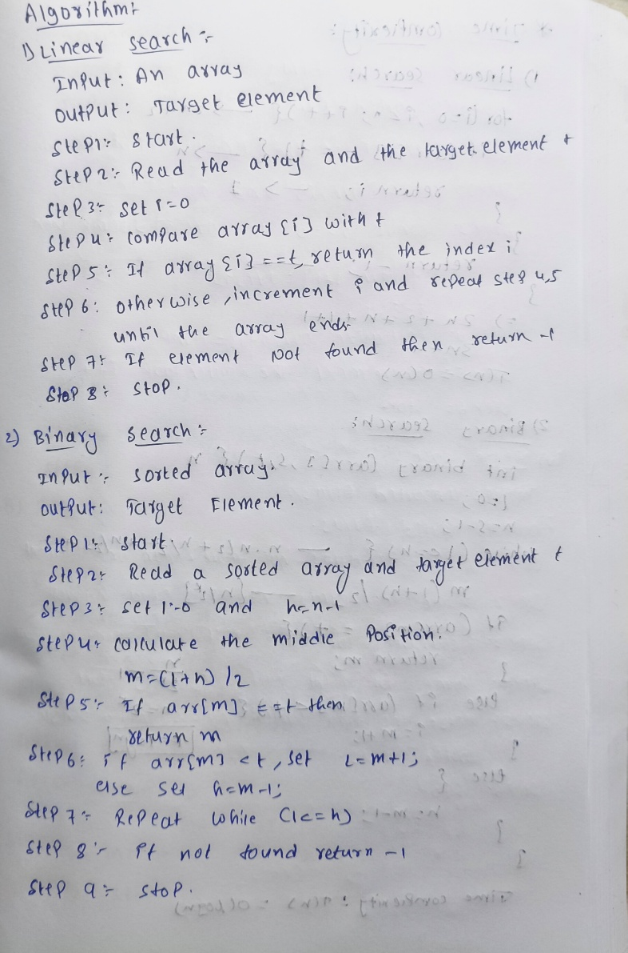

Program:

#include <iostream>
using namespace std;

// Linear Search
int linear(int array[], int s, int t) {
for (int i = 0; i < s; i++) {
if (array[i] == t) {
return i;
}
}
return -1;
}

// Binary Search
int binary(int array[], int s, int t) {
int l = 0;
int h = s - 1;

while (l <= h) {
int m = (l + h) / 2;

if (array[m] == t) {
return m;
}
else if (array[m] < t) {
l = m + 1;
}
else {
h = m - 1;
}
}

return -1;
}

// Display Array
void display(int array[], int n) {
cout << "Array is:\n";

for (int i = 0; i < n; i++) {
cout << array[i] << " ";
}

cout << endl;
}

int main() {

int array[] = {2, 6, 7, 9, 11};
int n = sizeof(array) / sizeof(array[0]);

int t = 6;

display(array, n);

int f = linear(array, n, t);
int g = binary(array, n, t);

cout << "\nTarget element: " << t << endl;

if (f != -1) {
cout << "Linear Search: Element found at index " << f << endl;
}
else {
cout << "Linear Search: Element not found" << endl;
}

if (g != -1) {
cout << "Binary Search: Element found at index " << g << endl;
}
else {
cout << "Binary Search: Element not found" << endl;
}

return 0;
}

Output:

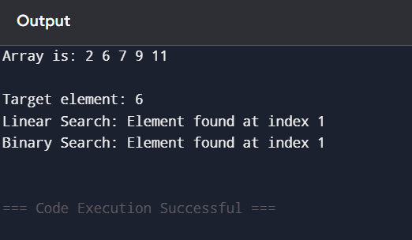

Time Complexity:

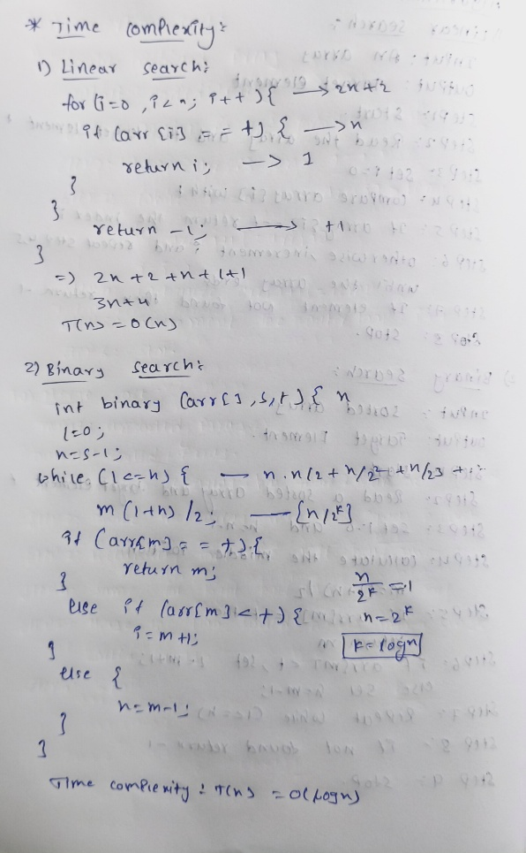

Conclusion:

Hence, the Linear Search and Binary Search algorithms were successfully implemented and executed. Their time complexities were analyzed in three cases: Best Case, Average Case, and Worst Case.

